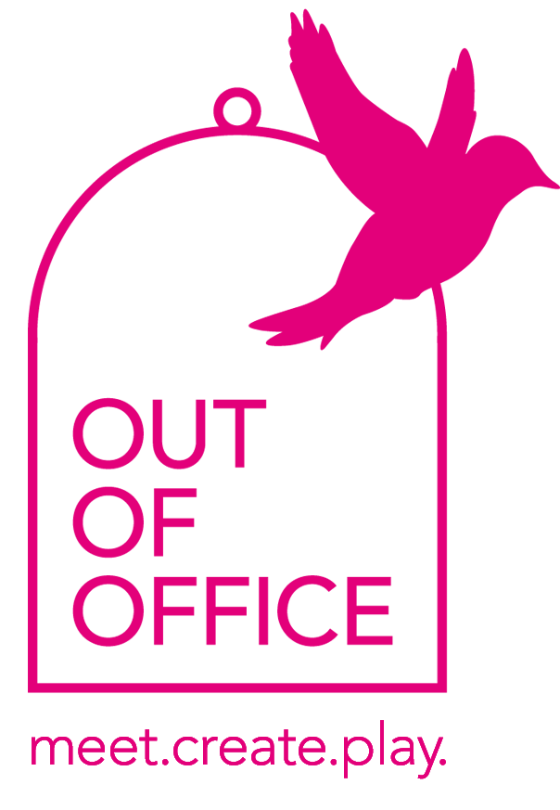
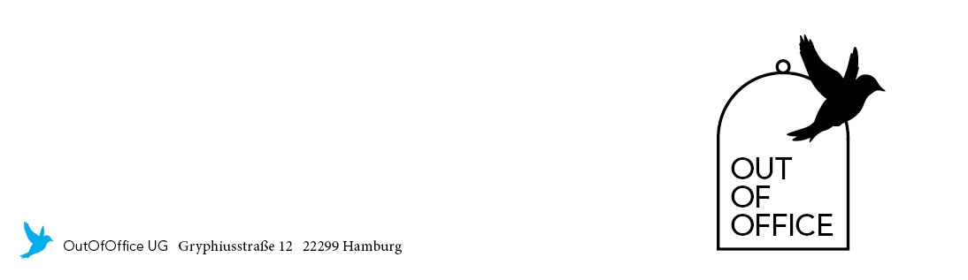
OutOfOffice München GmbH I Kolosseumstraße 1 I 80469 München
München

- 1 Flatscreen (65 Zoll)
- 2 Roll papers
- 1 Flipchart
- 2 Boards
- Sonos Soundsystem
- Free WiFi
- Moderation kit
- 25 chairs (at the table)
- 45 chairs (Theatre style)
- 2 Lounge Areas
- 1 movable wall
- Fully equipped kitchen
- 2 Espresso and coffee machines
- Barbecue on the terrace
- Elevator goes directly in the location
- Elevator H 215 cm x B 70 cm x T 120 cm
- Additional equipment on request
- Drinks and Snacks
- Catering for meetings and workshops – look up our menus
- Additional catering options on request
- Rooftop terrace for fresh air
- Exceptional view over the trendy Glockenbachviertel
- Feel like in your own livingroom

